Integer Data Types
# Source: AI Source: Provided by: [Data Path: Persons Table -> ID Column: 1, Name_En Column: Motasem Essam] -> From: [Chatgpt (GPT‑5 Mini)] on [12/10/2025]
Integer is a data type used in programming to store whole numbers (numbers without decimals or fractions).
Key Characteristics
- Stores positive numbers, negative numbers, and zero
- No decimal point
- Used for counting, indexing, loops, and calculations

Examples of Integer Values
# Source: AI Source: Provided by: [Data Path: Persons Table -> ID Column: 1, Name_En Column: Motasem Essam] -> From: [Chatgpt (GPT‑5 Mini)] on [12/10/2025]
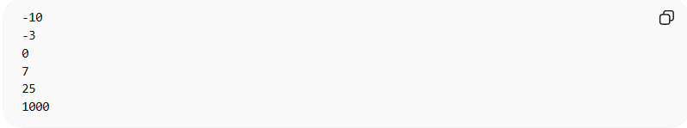
-10
-3
0
7
25
1000

Example in Programming

Python
# Source: AI Source: Provided by: [Data Path: Persons Table -> ID Column: 1, Name_En Column: Motasem Essam] -> From: [Chatgpt (GPT‑5 Mini)] on [12/10/2025]
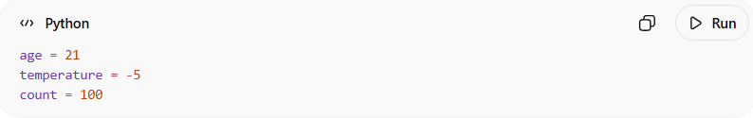
age = 21
temperature = -5
count = 100

C / C++ / Java
# Source: AI Source: Provided by: [Data Path: Persons Table -> ID Column: 1, Name_En Column: Motasem Essam] -> From: [Chatgpt (GPT‑5 Mini)] on [12/10/2025]
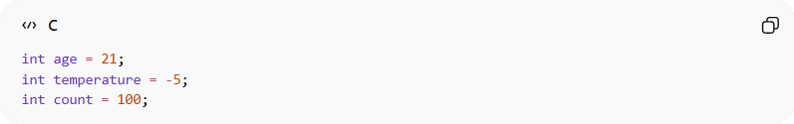
int age = 21;
int temperature = -5;
int count = 100;

Common Integer Types (depending on language)
# Source: AI Source: Provided by: [Data Path: Persons Table -> ID Column: 1, Name_En Column: Motasem Essam] -> From: [Chatgpt (GPT‑5 Mini)] on [12/10/2025]
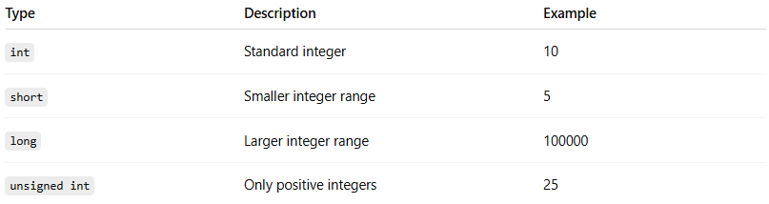
Type | Description | Example
int | Standard integer | 10
short | Smaller integer range | 5
long | Larger integer range | 100000
unsigned int | Only positive integers | 25

Where Integers Are Used
# Source: AI Source: Provided by: [Data Path: Persons Table -> ID Column: 1, Name_En Column: Motasem Essam] -> From: [Chatgpt (GPT‑5 Mini)] on [12/10/2025]
- Counting items
- Loop counters
- Array indexing
- Mathematical operations
- Storing quantities (age, number of students, etc.)

✔ Example Use Case
# Source: AI Source: Provided by: [Data Path: Persons Table -> ID Column: 1, Name_En Column: Motasem Essam] -> From: [Chatgpt (GPT‑5 Mini)] on [12/10/2025]
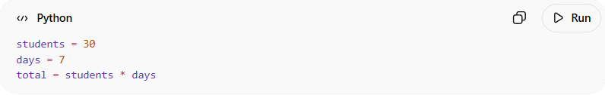
students = 30
days = 7
total = students * days
Result: 210

